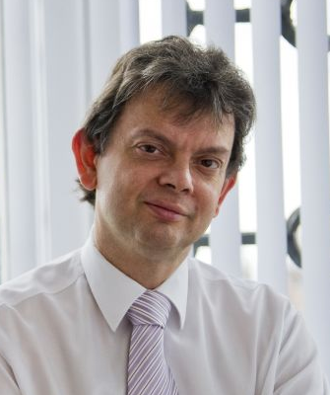
Professor Sir Anton Muscatelli FRSE AcSS
Principal and Vice-Chancellor

Professor Sir Anton Muscatelli has been Principal and Vice-Chancellor, University of Glasgow since October 2009. From 2007-2009 he was Principal and Vice-Chancellor of Heriot-Watt University. An economist, his research interests are monetary economics, central bank independence, fiscal policy, international finance and macroeconomics.
Sir Anton is a member of the University Grants Committee, Hong Kong and he is Chair of its Research Group. He was a Director of the UK Universities Superannuation Scheme (2015-2024), one of the largest private pension funds in the UK. From 2017-2020 he was Chair of the prestigious Russell Group of UK research-intensive universities. He has held numerous UK and Scottish government advisory roles including Chair of the First Minister of Scotland’s Standing Council on Europe, member of the Scottish Government’s Council of Economic Advisers and adviser to the House of Commons Treasury Select Committee. He has also advised the European Commission and the World Bank.
Sir Anton was knighted in 2017 for services to economics and higher education and was awarded the honour of Knight Commander (Commendatore) by the Republic of Italy in 2008 for contributions to higher education and economic science. He holds an honorary degree from McGill University in Canada.

